Software Requirements Specification (SRS)

Version: 1.0
Project Name: EveZen
Technology Stack: MERN Stack

1. Introduction
1.1 Purpose
EveZen is a web-based Institutional Event Management System developed to simplify the planning, scheduling, and management of events conducted within an educational institution. It provides a centralized platform where administrators can organize events, assign faculty and supporting staff, while students can register for events and securely verify their attendance using dynamic QR codes or OTP.

1.2 Scope
The system aims to digitize the entire event management process by reducing manual paperwork and improving communication among administrators, faculty, supporting staff, and students.
The application supports:
- Event planning and scheduling
- Venue management
- Faculty and supporting staff allocation
- Student event registration
- QR & OTP-based attendance
- Discussion forum
- Secure authentication
- Role-based access control

1.3 Objectives
The primary objectives of EveZen are:
- Simplify institutional event management.
- Reduce manual work in organizing events.
- Enable online student registration.
- Improve communication through announcements and discussion forums.
- Prevent attendance fraud using dynamic QR codes.
- Maintain accurate attendance records.
- Efficiently manage venues and staff assignments.
- Provide a secure and user-friendly platform.

2. Project Description:
EveZen is a centralized event management platform developed for colleges and universities. It allows administrators to create and manage events while assigning faculty members and supporting staff to ensure smooth event execution.
Students can browse upcoming events, register online, and obtain a secure QR code and OTP for attendance verification. Faculty members verify attendance through QR scanning or OTP validation. Supporting staff can view assigned events and participate in the discussion forum.

User Roles
The system supports four user roles:

Admin :  - Complete system control  - Event management  - Venue management  - Faculty management  - Supporting staff management  - Credential generation  - Forum administration | Faculty :  - View assigned events  - View registered participants  - Mark attendance  - Post announcements  - Participate in forum discussions
Student :  - Signup  - Login  - View upcoming events  - Register for events  - Generate QR code  - Generate OTP  - Participate in discussion forum | Supporting Staff :  - Login  - View assigned events  - View assigned venue  - Participate in forum discussions

3.Functional Requirements:
Module | Features / Functional Requirements
Authentication Module | Login: Email ID, Password. Supported Roles: Admin, Faculty, Student, Supporting Staff. Student Signup: Name, Email, Phone Number, Password, Confirm Password.
Admin Module – Dashboard | View today's events, upcoming events, total faculty members, total supporting staff, monthly event calendar, recent announcements, event participation statistics.
Admin Module – Event Management | Create, edit, delete and update events. Event details include Event Name, Description, Event Type (Individual/Team), Date, Time, Venue, Maximum Participants, Faculty Assignment, Supporting Staff Assignment. System validates faculty, venue and staff availability before confirmation.
Admin Module – Venue Management | Add, edit, delete venues, view available and booked venues, track venue usage.
Admin Module – Faculty Management | Create, edit, delete and update faculty details (Name, Email, Phone Number).
Admin Module – Supporting Staff Management | Add, update and delete supporting staff. Details include Name, Phone Number and Work Type (Cleaner, Electrician, Technician).
Admin Module – Credential Management | Generate login credentials for Faculty and Supporting Staff. Create accounts, reset passwords, activate/deactivate accounts.
Admin Module – Discussion Forum | Create announcements, pin announcements, delete messages and moderate discussions.
Student Module | Signup, login, view upcoming events, search events, filter individual/team events, register for events, generate QR Code and OTP after registration.
Dynamic QR System | Generates unique dynamic QR Code for each registered student. QR refreshes every 20 seconds, supports time-based authentication, prevents screenshots and expires automatically.
OTP System | Generates a six-digit OTP for attendance verification.
Faculty Module | View assigned events, event details, participant list, search participants, mark attendance using QR Code or OTP, view attendance records (Student Name, Register Number, Status, Time, Date), post and view announcements.
Supporting Staff Module | View assigned events, event venue, assigned responsibilities, event schedule, post discussion messages and view discussions.
Discussion Forum | Admin: Post, delete, pin announcements, moderate discussions. Faculty: Post announcements, view discussions. Student: View posts, create discussion posts, comment on discussions. Supporting Staff: View discussions, create discussion posts.

4. Non-Functional Requirements

Category | Requirements
Security | JWT Authentication, bcrypt Password Hashing, Role-Based Access Control (RBAC), Protected REST APIs, Secure Session Management, Dynamic QR Security, OTP Expiration, Input Validation, MongoDB Injection Protection
Performance | Fast page loading, Response time below 2 seconds, Efficient database queries, Pagination for large datasets
Reliability | Automatic error handling, Database backup support, Proper logging, Consistent API responses
Scalability | Support for multiple departments, Thousands of students, Hundreds of events, Concurrent users
Usability | Responsive design, Mobile-friendly interface, Easy navigation, Bootstrap-based UI, Simple user experience

5. System Requirements :

Hardware :  - Laptop/Desktop  - Minimum 8 GB RAM  - Intel i5 or equivalent  - Stable Internet Connection | Software :  - IDE - Visual Studio Code  - Browser - Google Chrome  - Database - MongoDB  - Backend - Node.js, Express.js  - Frontend - React.js, Bootstrap 5  - API - REST API  - Version Control - Git, GitHub

6. System Architecture

Frontend  - React.js  - Bootstrap 5  - React Router  - Axios | Backend  - Node.js  - Express.js
Database  - MongoDB  - Mongoose ODM  API  - REST API | Modules  - Authentication API  - Event API  - Venue API  - Faculty API  - Supporting Staff API  - Student API  - Registration API  - Attendance API  - Forum API

7. Database Collections :
- Users
- Students
- Faculty
- Supporting Staff
- Events
- Venues
- Event Registrations
- Attendance
- Discussion Forum

8. Assumptions :
- Every user has a unique email address.
- Only administrators can create faculty and supporting staff accounts.
- Every event is assigned one venue.
- Faculty and supporting staff cannot be assigned to overlapping events.
- Students can register only before the registration deadline.
- QR codes expire automatically after 20 seconds.

9. Constraints
- Internet connection is required.
- MongoDB server must be available.
- Modern browsers are required.
- JWT token expiration applies to all users.
- Maximum event capacity cannot be exceeded.

10. Future Enhancements :
- Mobile application (Android/iOS)
- Email notifications
- SMS reminders
- Push notifications
- Event feedback and ratings
- Certificate generation
- AI-based event recommendations
- Analytics dashboard with charts
- Department-wise event management
- Multi-college support
- Calendar synchronization with Google Calendar
- Event report generation in PDF/Excel

11. ER diagram :
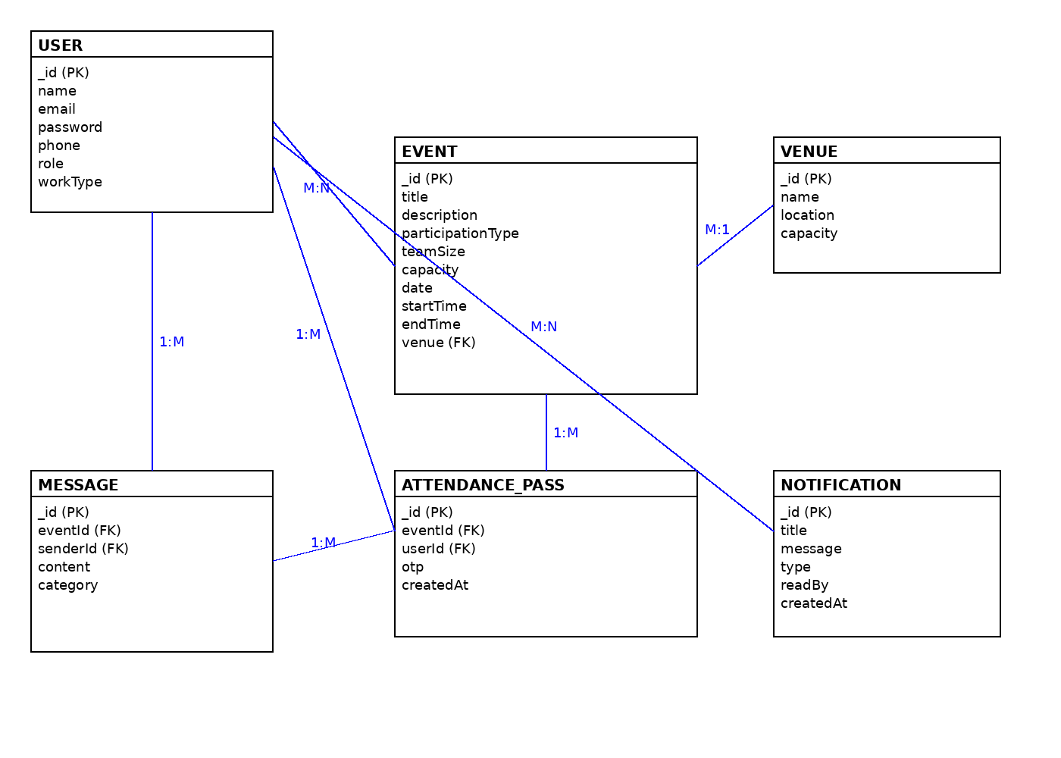

12. Conclusion :
EveZen is designed to provide a secure, efficient, and centralized solution for institutional event management. By integrating role-based access control, online event registration, dynamic QR code attendance, OTP verification, venue and staff management, and a collaborative discussion forum, the system streamlines event organization while improving transparency, reducing manual effort, and enhancing the overall experience for administrators, faculty, supporting staff, and students.

